Q1) Write a C program to count total number of digits of an Integer number (N).

Sample Test Cases

Test Case 1

Input

3456

Output

The number 3456 contains 4 digits.

Test Case 2

Input

30000

Output

The number 30000 contains 5 digits.

Test Case 3

Input

57

Output

The number 57 contains 2 digits.

Test Case 4

Input

909

Output

The number 909 contains 3 digits.

**For example:**

| **Input** | **Result** |
| --- | --- |
| 3456 | The number 3456 contains 4 digits. |
| 30000 | The number 30000 contains 5 digits. |
| 57 | The number 57 contains 2 digits. |
| 909 | The number 909 contains 3 digits. |
|  |  |

Answer:(penalty regime: 0 %)

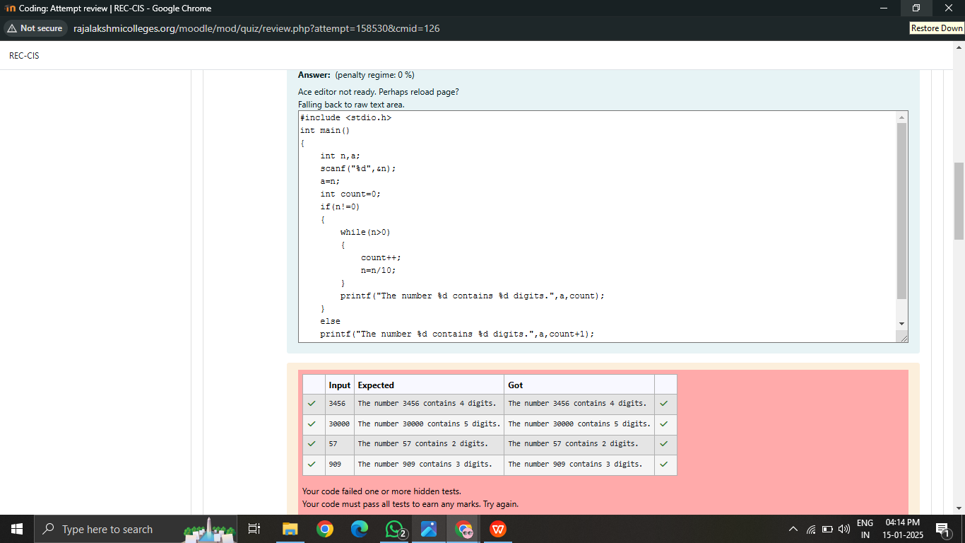

Q2) Write a C program to check whether the given number(N) can be expressed as Power of Two (2) or not.

For example, 8 can be expressed as 2^3.

**Sample Test Cases**

**Test Case 1**

**Input**

8

**Output**

8 is a number that can be expressed as power of 2.

**Test Case 2**

**Input**

46

**Output**

46 cannot be expressed as power of 2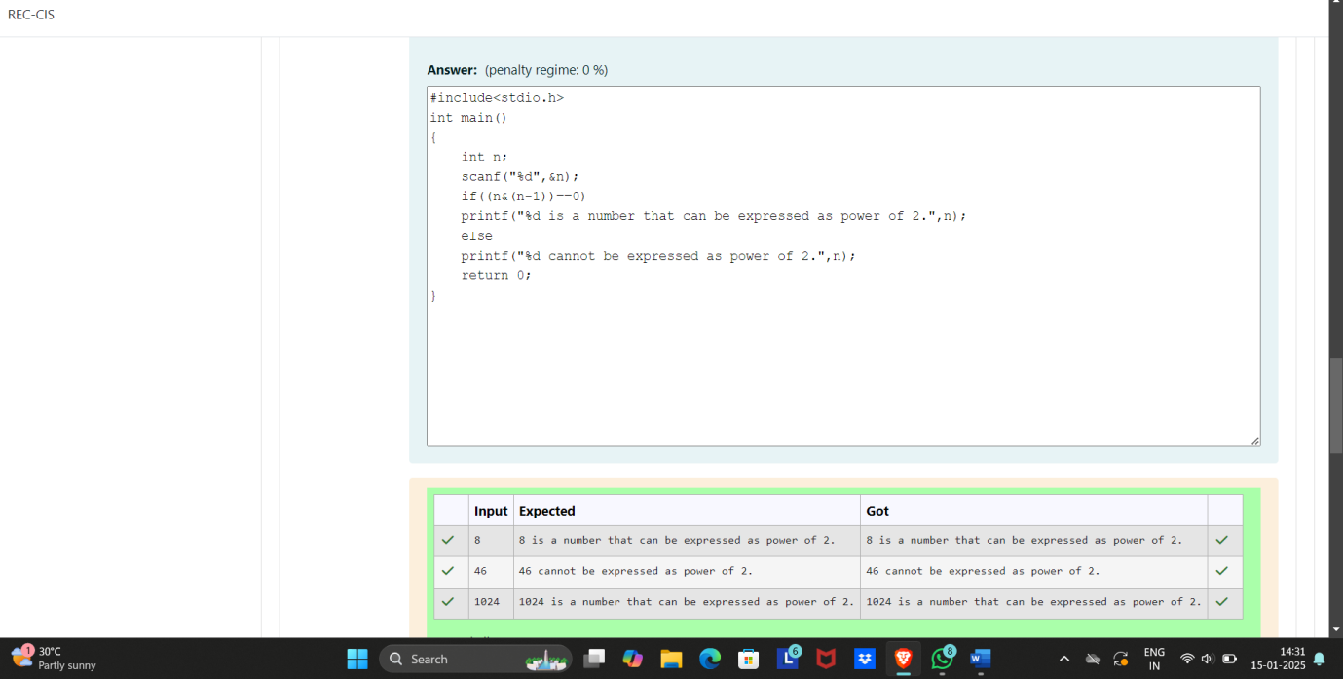

Q3) Write a program in C to find the sum of the series 1 +11 + 111 + 1111 + . . . + n terms (n will be given as input from the user and sum will be the output)

**Sample Test Cases**

***Test Case 1***

**Input**

4

**Output**

1234

***Test Case 2***

**Input**

6

**Output**

123456